A Minor Project Report
On

AUTOMATIC LOAD SHARING OF TRANSFORMER USING ARDUINO

BY

- MD ZAFAR (21103134035)
- KRITI KUMARI (21103134036)
- ABHINAV KUMAR (22103134913)
- VARSHA KUMARI (22103134916)
- ANKIT KUMAR (21103134033)
- ALKA KUMARI (21103134025)
- RUPESH KUMAR (22103134905)
- KUMARI BEAUTY RANI (22103134915)

DEPARTMENT OF ELECTRICAL ENGINEERING

GOVERNMENT ENGINEERING COLLEGE
BANKA – 813102
DECLARATION

a) The work contained in the minor project report is original and has been done by ourselves under the general supervision of my supervisor.

b) The work has not been submitted to any other Institute for any degree or diploma.

c) We have followed the guidelines provided by the Institute in writing the report.

d) We have conformed to the norms and guidelines given in the Ethical Code of Conduct of the Institute.

e) Whenever we have used materials (data, theoretical analysis, and text) from other sources, we have given due credit to them by citing them in the text of the report and giving their details in the references.

(signature): …………… (signature): …………
Name: ………………… Name: ………………
Reg no: ……………….. Reg no: ……………..

(signature): …………… (signature): …………
Name: ………………… Name: ……………...
Reg no: ……………….. Reg no: ……………..

(signature): …………… (signature): ………..
Name: ………………… Name: ……………..
Reg no: ……………….. Reg no: ……………

(signature): …………… (signature): ………..
Name: ………………… Name: …………….
Reg no: ……………….. Reg no: ……………

APPROVAL OF THE SUPERVISOR(S)

Recommended that the minor project report entitled “AUTOMATIC LOAD SHARING OF TRANSFORMER USING ARDUINO ” prepared by Md Zafar (21103134035), Kriti kumari (21103134036), Abhinav Kumar (22103134913),Varsha Kumari (22103134916), Ankit Kumar (21103134033), Alka Kumari (21103134025), Rupesh Kumar (22103134905), Kumari Beauty Rani (22103134915) .under my/our supervision and guidance be accepted as fulfilling this part of the requirements for the award of degree for bachelor of Technology in Electrical engineering.

To the best of my/ our knowledge the contents of this report did not form a basis for the award of any previous degree to anyone else.

Date: ………….

Place: ……….

(Signature)

(Prof. Sujit Kumar)

Supervisor

Asst. professor

Department of Electrical Engineering

Government Engineering College Banka

CERTIFICATE OF APPROVAL

This is to certify that minor project work embodied in this report entitled “AUTOMATIC LOAD SHARING OF TRANSFORMER USING ARDUINO” is carried out by Md Zafar (21103134035), Kriti kumari (21103134036), Abhinav Kumar (22103134913),Varsha Kumari (22103134916), Ankit Kumar (21103134033), Alka Kumari (21103134025), Rupesh Kumar (22103134905), Kumari Beauty Rani (22103134915). Is approved for the degree of Bachelor of Technology (7th Semester) in Electrical Engineering of Government Engineering College Banka.

Date: …….

Place: …….

Internal Examiner Head of the Department Internal Examiner
Name & signature Electrical Engineering) Name& signature

ACKNOWLEDGEMENT

I would like to express our gratitude towards all the people who have contributed their precious time and efforts to help us in completing this Minor Project without whom it would not been possible for us to complete this work.

I would like to thanks my project Supervisor Prof. Sujit Kumar, Asst. Professor, Department of Electrical Engineering for his guidance, support, motivation and encouragement during the project period. His readiness for consultation at all times, his educative comments, his concern and assistance have been invaluable.

I am also grateful to Prof. Atul Choudhary, Asst. Professor and Head of the Department of Electrical Engineering, for providing the necessary facilities in the department.

I like to thanks my Parents and friends for their constant motivation, help and moral support throughout the length of this project report.

(signature): …………… (signature): …………
Name: ………………… Name: ………………
Reg no: ……………….. Reg no: ……………..

(signature): …………… (signature): …………
Name: ………………… Name: ……………...
Reg no: ……………….. Reg no: ……………..

(signature): …………… (signature): ………..
Name: ………………… Name: ……………..
Reg no: ……………….. Reg no: ……………

(signature): …………… (signature): ………..
Name: ………………… Name: …………….
Reg no: ……………….. Reg no: ……………
Abstract
In the realm of electrical power distribution, transformers are indispensable but susceptible to inefficiencies and potential damage when overloaded. To address this challenge, this project aimed to develop an automated load-sharing system between primary and backup transformers, utilizing Arduino microcontrollers. The system's core function is to optimize transformer performance, prevent overloads, and ensure continuous power supply. The methodology involved integrating sensors and a dynamic switching mechanism controlled by an Arduino. This configuration allows for the detection of abnormal load conditions. Upon detecting an overload on the primary transformer, the Arduino activates the backup transformer to balance the load, thereby mitigating thermal stress on the equipment. Furthermore, the system enables seamless alternation between transformers during normal load conditions, facilitating maintenance activities without disrupting power supply. The project's outcome has proven highly advantageous, enhancing the reliability of the power distribution system, reducing operational risks, and extending the lifespan of transformers. This innovative integration of technology and functionality has significantly improved the management of transformer loads. Looking towards the future, the project possesses substantial potential for further advancements. Future enhancements could include the integration of Internet of Things (IoT) technologies for real-time monitoring and control, the utilization of advanced sensor technologies for more precise load management, the incorporation of energy storage systems to buffer loads, the application of machine learning algorithms for predictive maintenance, and considerations for environmental impact. These enhancements will not only improve the systems efficiency and scalability but also its integration into the broader power grid, thereby advancing the field of smart power distribution.

Chapter 1
Introduction
1.1 General
In this work paper proposed a project on the automatic load sharing transformer using as is predefined that there is a lot of variations in the load which is connected to the transformer because of the consumer demand. Also we know that a transformer is rated for a specified load capacity and also it has its own rating so that we can connect the load not exceeding to its rating.If the loads are connected to the transformer and it will be further increasing and increasing then there will be more burden on the specified transformer and its winding. So that the winding of the transformer may burn out. As the transformer is very important and more expensive component in the power system, so it is very necessary to protect them from damage and insure the reliability. This project is all about protecting the transformer under overload condition by connecting another transformer through a microcontroller and a relay which senses the excess load of the first transformer. In case to reduce the excess load burden on the transformer it is necessary to use another transformer in parallel with it such that the load can be shared between both the transformer in the ratio of its KVA rating.We can understand this as parallel operation of the transformer. It is not economical to operate both the transformer at every time that means under normal condition and overload condition. It is required to us of another transformer when it is requird that means when there is an exceeding of load demand . And when the load is exceeding and the limit of the transformer to supply the power is crossed from its predefined value , now it is necessary to connect the another transformer in parallel with it. So that the load can be shared by the another transformer and the first one can be protected.
- For doing so the manual operation can be performed.
- If the connection of another transformer will be automatic it will become more reliable efficient and real time execution.
The automatic operation will become more reliable as compare to manual one , since there some extra sensors can be added to it, so that it senses the load expansion and give alarm to the the controlling unit if required, and even an extra circuit with microcontroller is added to it so that it can automatically connect the another transformer in parallel with the first transformer. And after that the circuit can be protected . Also it ensures the continuity of the supply system as there is less chance of the power failure during maintenance and fault in the single transformer. The transformers are switched alternatively to avoid thermal overloading therefore two transformers work efficiently under overload condition and damage can be prevented. If there is further increase in the load beyond the capacity of two transformer there will be a priority based load shedding of consumers which will provide uninterrupted power supply to the hospitals industries etc. Since it ensures the reliability of the system hence it is overall very necessary to use the concept of AUTOMATIC LOAD SHARING OF TRANSFORMER .

Chapter 2
Literature Reviews

2.1 INTRODUCTION
Transformers is one of the major apparatuses in the electrical power system, therefore transformer needed protection. Besides this the requirement of electricity is increasing with the increasing population and their unavoidable demands, with this increased power requirement, the existing systems have become overloaded. The overloading appears at the consumer end of the transformer terminals, which can affect its efficiency and protection systems. Because of overloading to the transformer, the efficiency declines and the windings gets overheated and gets burnt. It takes many times to repair and large expenditure. Transformers are sometimes loaded beyond nameplate ratings due to possible existing contingencies in the transmission lines, power systems failure or fault, or economic grounds. One of the damage or tripping that reported was: of the distribution transformer is attributed to thermal overload. Overloading from consumer end and damaging of transformers is something that can be avoided and it involves the control against over current tripping of distribution transformer. An increase in the operating temperature of the transformer. The project is all about protecting the Transformer under over-load condition. by connecting another transformer in parallel through Arduino and a relay which shares the surplus load of the first transformer. The transformers are switched alternately to avoid thermal overloading. Thus, two transformers work efficiently under overload condition and damage can be prevented. An increase in load over the ability of two transformers will again result in a priority-based load shedding of consumers which will provide un-interrupted power supply for the hospitals, industries etc.
2.2 Automatic load sharing of transformer
An Automatic Load Sharing Transformer (ALST) is a type of transformer system designed to evenly distribute electrical load among multiple transformers operating in parallel without manual intervention. Automatic Load Sharing Transformers are highly efficient in distributing electrical loads evenly across multiple transformers, ensuring stable voltage regulation, reduced energy losses, enhanced reliability, and improved power quality. They dynamically adapt to changing load conditions, minimize maintenance needs, and prevent overloading, making them essential for efficient and reliable power distribution systems. Automatic Load Sharing Transformers are essential for modern power systems to ensure efficiency, reliability, and balanced load distribution across multiple transformers.
V.N Chatse et al., [1] had proposed automatic load sharing in the transformer improves efficiency, reliability and safety of the power system by using IoT. reliability, and safety of power systems. It stops overloads and keeps the load balanced, making transformers work better and last longer. With real-time monitoring, temperature control, and automated load management, the power supply stays stable, lowering costs and reducing problems. IoT- based automatic load sharing system help distribute load efficiently, protecting transformer and ensuring a reliable power supply. This method protects the infrastructure and helps energy management grow, benefiting both industries and homes while supporting sustainable national growth.
Yogesh K. Kirange et al.,[2] had investigated that using an automatic load-sharing system with Arduino UNO makes power distribution better. It helps manage power between main and backup transformers, stopping overloads, reducing risks, and keeping power on. it prevents overloading, minimizes operational risks, and ensures uninterrupted power supply. The system needs less manual work, uses resources better, and makes transformers last longer. In the future, we could include IoT, machine learning for maintenance, and better monitoring to make it even better for today's modern power distribution network.
Shailesh G. Thakre et al.,[3] had demonstrated in Load Sharing of Transformer Using Microcontroller that the parallel operation of transformers, managed automatically through a microcontroller, can effectively protect transformers under overload conditions, prevent damage, and ensure uninterrupted power supply. By sharing the load between two transformers, the
system increases reliability, avoids overheating, and maintains efficiency. The automation eliminates manual intervention and optimizes transformer operation particularly under increasing load demands.
Krushna K. Tormad et al.,[4] had proposed in load Sharing of Transformers Automatically by Using Arduino with GSM that this paper shows that the automatic load-sharing system provides uninterrupted power supply and protects transformers from overloading and overheating. It increases the efficiency and reliability of the system while reducing human intervention. The system allows for alternating switching between transformers, enabling natural cooling and ensuring continuous power delivery.
Prafull Pawar et al.,[5] had investigated in automatic Load Sharing of Transformer by Using PLC. In This paper focuses on PLC-based load sharing between transformers to prevent damage caused by overloading and overheating. By connecting transformers in parallel through PLC control, load distribution is automatically managed when one transformer exceeds its capacity. This setup enhances reliability, reduces costs, and ensures uninterrupted power supply to consumers. The system eliminates the need for manual intervention, reduces transformer stress, and prolongs the equipment's lifespan.
Aniket Kuntawar et al.,[6] studied the potential of load sharing between transformers for substation applications. By intelligently sharing the load between transformers, the system avoids unnecessary operation of multiple transformers during off-peak hours, leading to substantial energy savings and reduced operational costs. Furthermore, the automated connection of additional transformers during peak loads ensures reliable power supply and prevents system overload.
Vivek Vishnupant Chouguler et al.,[7] monitored the parameters and discovered that if the load on one transformer increases, the relay will sense the change in current, the microcontroller will activate, and slave transformers will immediately activate to share the load. They designed and tested the work on ‘Automatic load sharing transformers’ and fabricated a demo unit for operating three transformers in parallel to automatically share the load with the help of a change over relay and relay driver circuit, as well as to protect the transformers from overloading and thus provide an uninterrupted power supply to the customers.
Natumanya Akimu et al.,[8] outlined the main objective of his project being ‘to monitor an over load in the system’. By use of current sensors, then cut off the overloaded line leaving the other lines safe and supplying electricity to their locations. This project uses current sensors, Arduino and relays to cut off the overloaded line. In this way, the automation process is carried out. This is a simple prototype. Using this as a reference further it can be expended to many other programs.

2.3 Objectives

- Protect transformers from overloaded condition by sharing the load.
- To measure the current and load in watt of both the transformers.
- To monitor the loading on both the transformers.
- To calculate the percent of overload condition on transformer.

Chapter 3
Methodology

3.1 LIST OF COMPONENTS USED:

S.NO. | COMPONENT | RATING | QUANTITY
01 | Transformer | 230V/2A | 2
02 | Current Sensor | ACS712ELCTR-05B-T | 1
03 | Capacitor | AVX0402XRIN | 1
04 | LCD Display | 16X2 | 1
05 | Relay | 5V | 1
06 | Arduino Uno | R3 | 1
07 | Switch |  | 3
08 | Motor/ LEDs/ Load | 12V | 15

3.2 Description:

- A transformer is a passive electrical device that transfers electrical energy between two or more circuits through electromagnetic induction. Primarily used to "step up" or "step down" AC voltages, it consists of a primary winding (the input coil), a secondary winding (the output coil), and a core, a magnetic material that facilitates the transfer of magnetic flux.

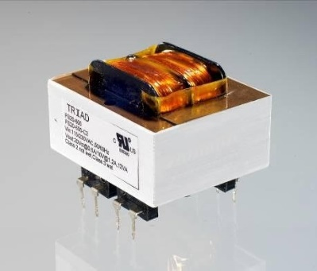

Fig. 1 (Transformer)

- A current sensor measures the electrical current flowing through a conductor without breaking the circuit. Often used for monitoring current in real-time for various applications like overcurrent protection, energy monitoring, and motor control, common types include Hall effect sensors, Rogowski coils, and current transformers.

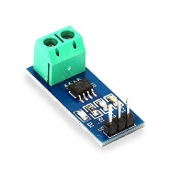
Fig. 2 (Current Sensor)

- A capacitor is an electrical component that stores electrical energy in an electric field. Composed of two conductive plates separated by an insulating material (dielectric), capacitors find applications in filtering AC signals, smoothing DC power supplies, and timing circuits.

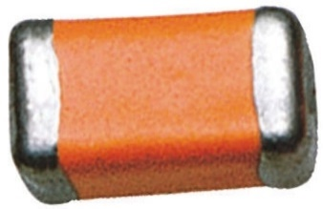

Fig. 3 (Capacitor)

- An LCD display is a type of flat-panel display that utilizes liquid crystals to form images. Renowned for their low power consumption and clear visibility in various lighting conditions, LCD displays are widely used in calculators, digital watches, and instrument panels.

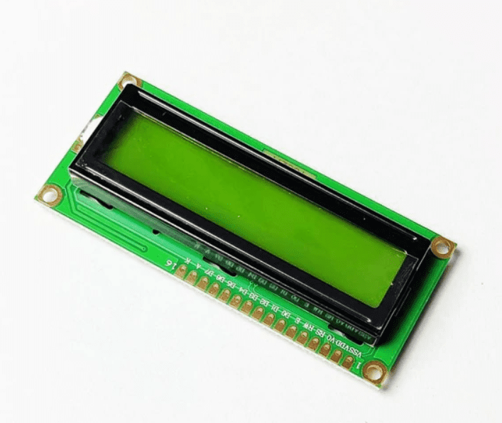

Fig. 4 (LCD Display)

- A relay is an electrically operated switch that opens or closes an electrical circuit. Employed to control high-power circuits with low-power signals, relays can be electromechanical or solid-state
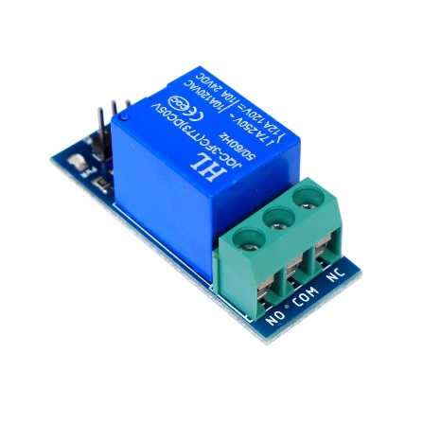
Fig. 5 (Relay)

- The Arduino Uno is a popular open-source microcontroller board based on the ATmega328P microcontroller. Serving as a platform for developing and prototyping electronic projects, it offers digital and analog input/output pins, a power supply, and an in-circuit serial programming (ISP) header.
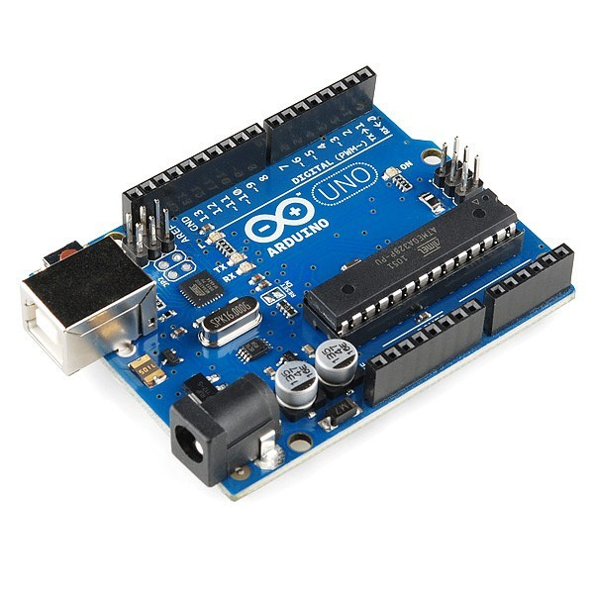
Fig. 6 (Arduino UNO)

- A switch is a device used to interrupt or complete the flow of electric current in a circuit. Switches can be manual, such as toggle switches or push buttons, or automatic, such as relays or sensor-activated switches.


Fig. 7 (Switch)

3.3 CONNECTION SCHEME:

First Arduino Uno is connected with the LCD display and relay or current sensor.
LCD display is connected through ports – 2,3,4,5,6,7.
Relay is connected through port – 13.
Relay LED is connected through port – 12.

Current Sensor Specifications:
Vcc = 5V
Vout = AO
GND – GND

3.4 CIRCUIT CONNECTIONS:

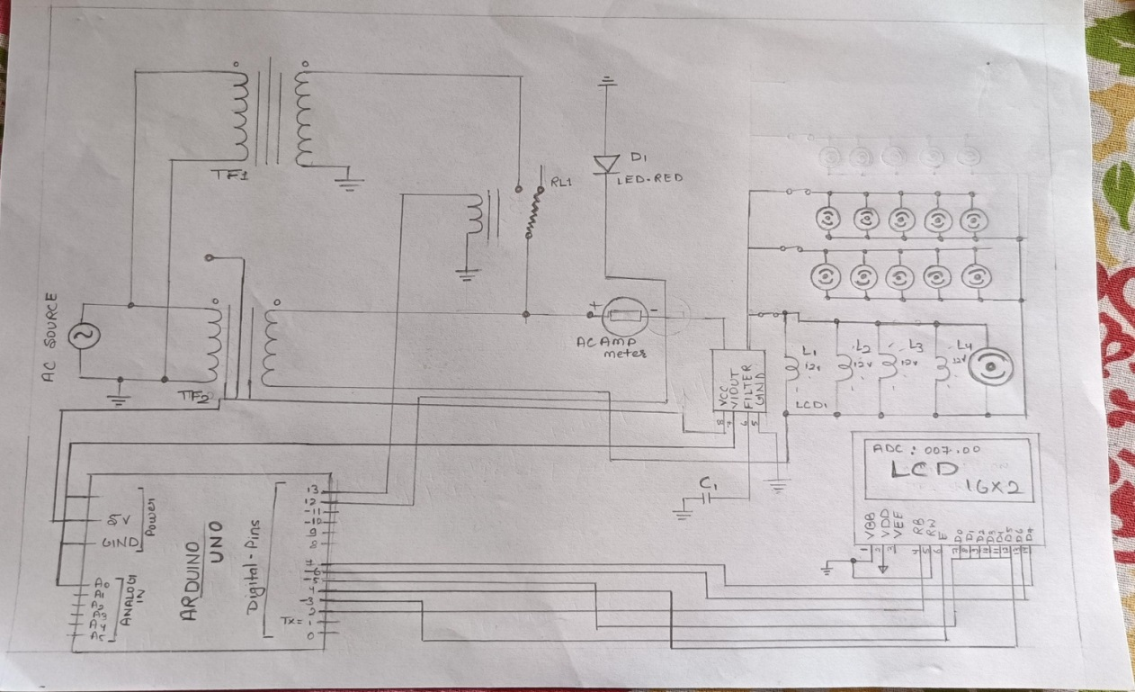
Fig.8 (Circuit digram)

ARDUINO and LCD Connection-
Digital pin Arduino-
7654- LCD-
4- D4
5- D5
6- D6
7- D7
LCD Pin E – Arduino Pin
Digital Pin =2

3.5 LOOK UP TABLE
S. No. | CONDITION | SWITCH  (ON) | DISPLAY |  |  | LOAD SHARING  (A) |  | LOAD in Watts
 |  |  | T1 | T2 | Total Load (A) | T1  (A) | T2  (A) | T1 | T2 | Total Load
01 | No load | OFF | OFF | OFF | 0 | 0 | 0 | 0 | 0 | 0
02 | Normal load | S1 ON | ON | OFF | 1.03 | 1.03 | 0 | 236.9 | 0 | 236.9
03 | Balanced load | S2 ON | ON | OFF | 2.64 | 2.64 | 0 | 607.2 | 0 | 607.2
04 | Overload | S3 ON | ON | ON | 4.9 | 2.1 | 2.1 | 483 | 483 | 966

Chapter 4
Results & Discussion

In this work, the simulation was conducted using proteus software. Figure 4 shows the simulation diagram of the automatic load sharing of transformer system.
The simulation demonstrates four modes of operation: "No load" and "Normal load" ”balanced load”, “Over load” each explained in
detail. fig. 4 shows the simulation diagram of the automatic load sharing of transformer system.

- No Load Mode

When no load condition is 0
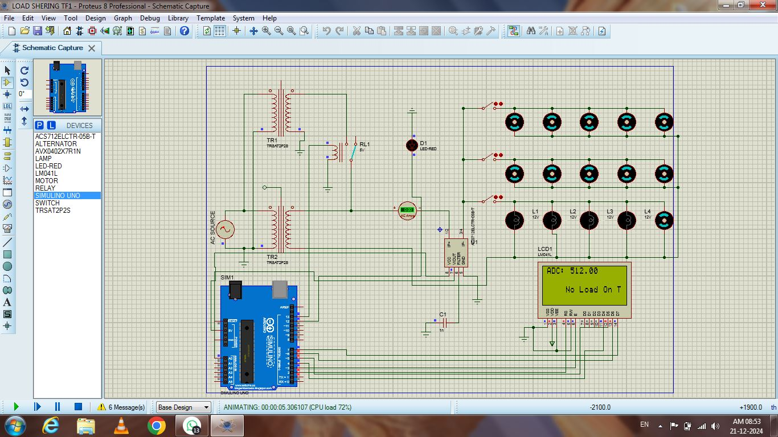
Fig. 1 (a) No Load Mode
- In the above figure five bulbs are connected in switches is e g, S1, S2, S3, and based upon the all switches is off stage load 0.0A. Relay is OFF condition. This means transformer 1 will be inactive and transformer 2 will be also inactive hence the LCD shows 512.

- Normal Load Mode

When normal load condition < 1
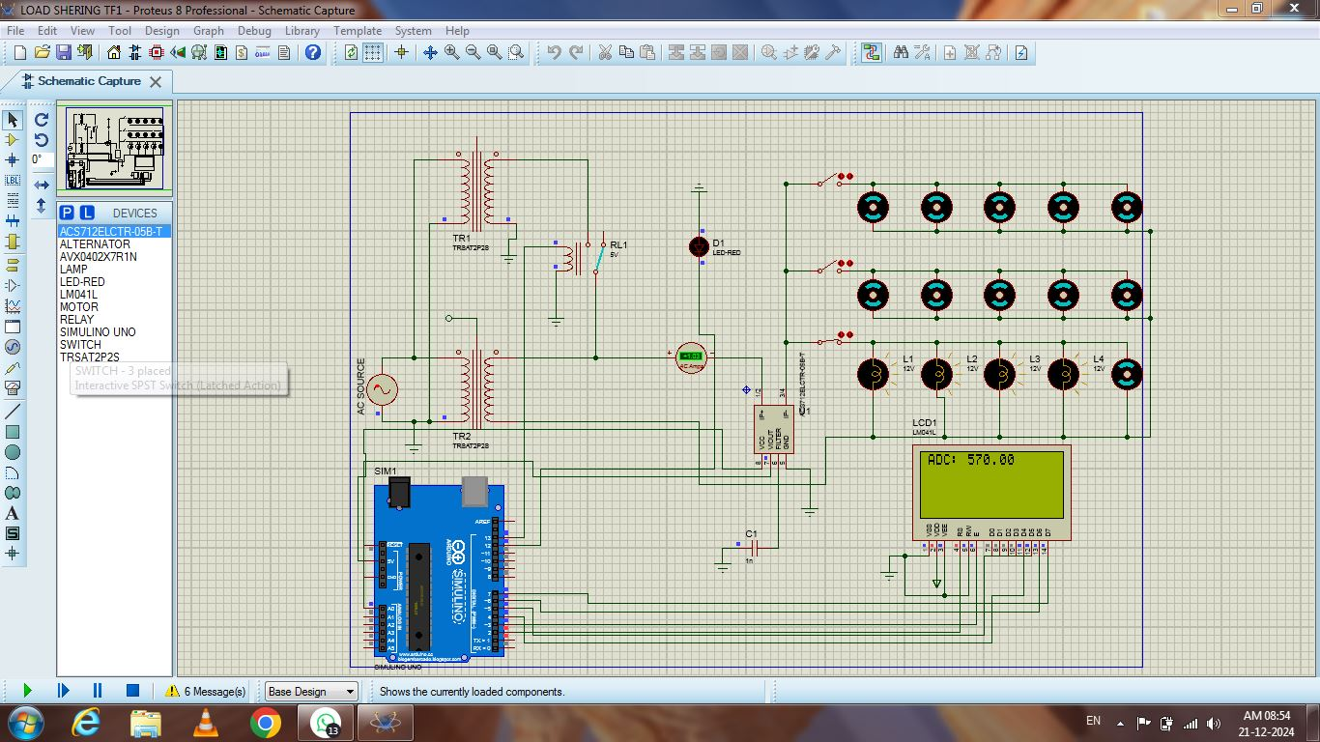
Fig. 2 (b) Normal Load Mode

- .In the above figure five bulbs are connected with switches in parallel S1 is ON load is 1.03A. Relay is OFF condition. This means transformer 1 will be active and transformer 2 will be also inactive hence the LCD shows 570.

- Balanced Load Mode

When balanced load condition < 2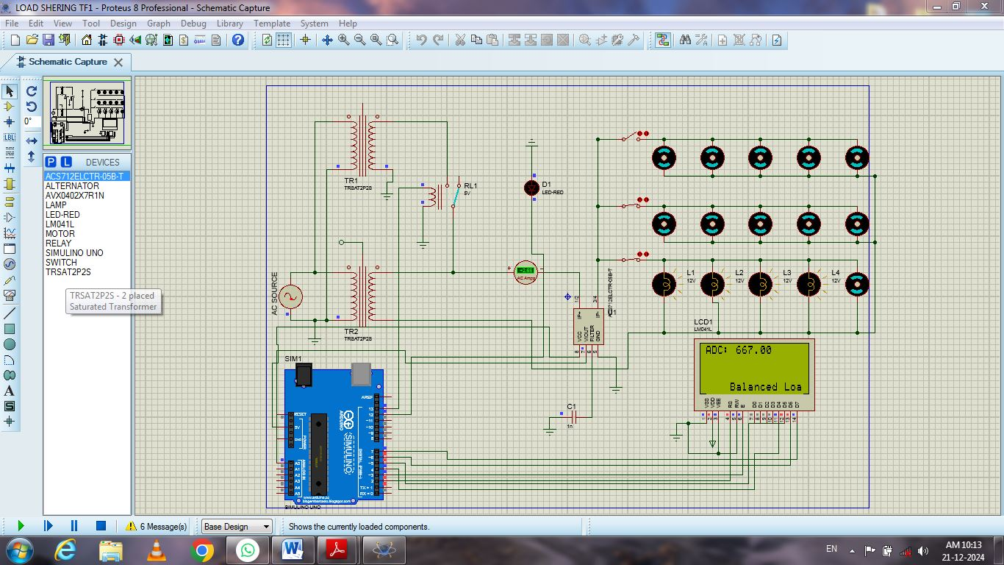
Fig. 3 (c) Balanced Load Mode

- .In the above figure five bulb are connected is S2 in ON and based upon the load is 2.64A. Relay is OFF condition. This means transformer 1 will be active and transformer 2 will be also inactive hence the LCD shows 667.

- Over Loading Mode

When over load condition is < 4
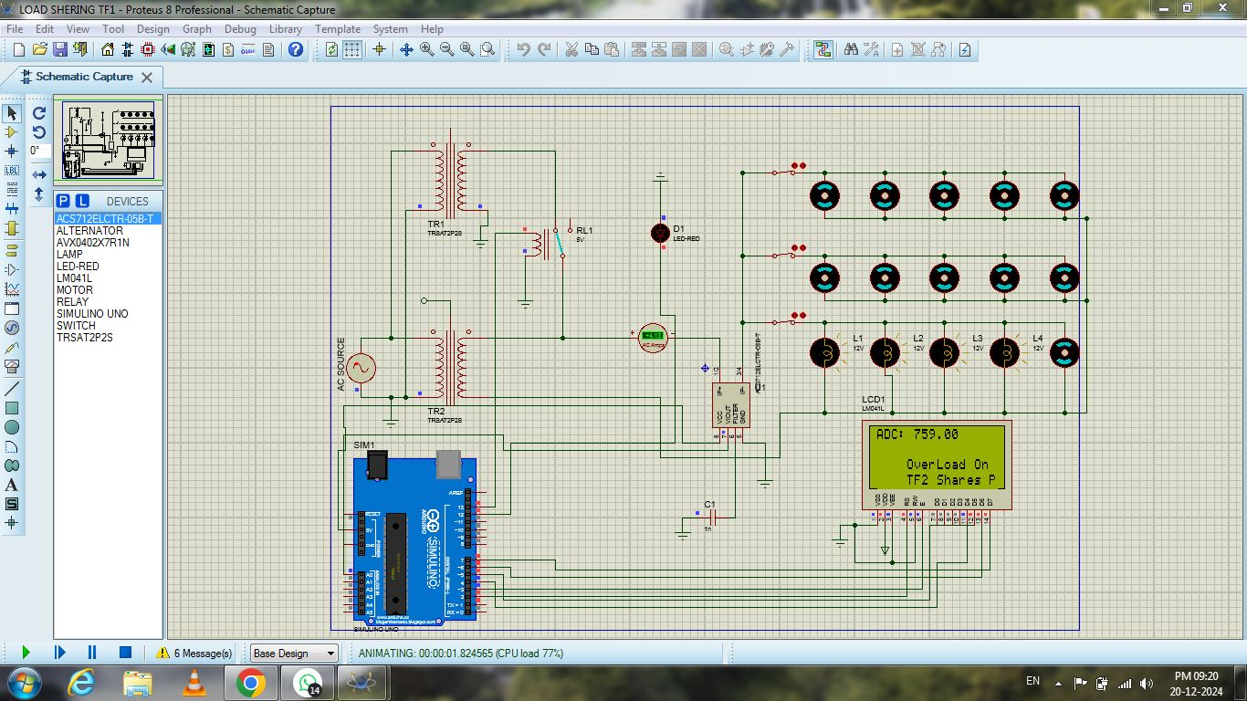
Fig. 4 (d) Over Loading Mode

- .In the above figure five bulbs are connected in S3 is ON and based upon the load is 4.9A. Relay is ON condition. This means transformer 1 will be active and transformer 2 will be also active hence the LCD shows 759.

Chapter 5
Conclusion & future work

The implementation of an automatic load sharing transformer in this project has demonstrated its potential to improve the efficiency, reliability ,and sustainability of power distribution systems. Through real-time monitoring and control, the system ensures optimal load distribution across multiple transformers, preventing overloads and enhancing overall system performances.
By preventing transformer overloading and ensuring uninterrupted power supply, the system contributes to a more sustainable and resilient energy infrastructure. Automatic load sharing transformer are already a valuable technology in power distribution system, ensuring reliable and efficient power delivery .
Here are some we can expect to see further developments .
- Integration with smart grid technologies :
- Enhanced load balancing and efficiency:
- Integration with renewable energy sources:
- Modular and scalable designs:
By embracing these advancements, automatic load sharing transformer can continue to play a vital role in ensuring a reliable, efficient, and sustainable power grid for the future.

REFERENCES

- Prafull Pawar, Nitin Gite, Manoj Sonawane, “Automatic Load Sharing of Transformer By using PLC”, International Research Journal of Engineering and Technology (IRJET), Volume: 07 Issue: 07 | July 2020.
- Shailesh G. Thakre, Pratima S. Komtolu, Abhishek V, Bisen, Saurabh D. Thengadi, Ajit M. Lilhare,” AUTOMATIC LOAD SHARING OF TRANSFORMER USING MICROCONTROLER”, International Research Journal of Modernization in Engineering Technology and Science ,Volume:04/Issue:04/April-2022.
- Yogesh K. Kirange, Dr. V. S. Patil, Rupesh S. Patil, Rohan Jagdish Patil, Pawara Dakshata Pandit, ” Optimizing Power Distribution: Smart Load Sharing Mechanism Enhanced by Arduino UNO Integration”, International Journal of Ingenious Research, Invention and Development, Volume 3 | Issue 2 | April 2024.
- Krushna K. Tormad, Dhiraj A. Nikalje Ishwar H. Patil, Dhanashree A. Gayakhe,” Load Sharing of Transformers Automatically by using Arduino with GSM”, IC-RTETM-2022 Organized by GGSF's GGS Polytechnic, Nashik.
- V.N Chatse , G.D. Shingade,”Automatic Load Sharing of Distribution Transformer (IOT)”. International Journal for Research in Applied Science & Engineering Technology (IJRASET), Volume 12 Issue VI June 2024.
- Aniket Kuntawar, Kamlesh Bawane, Ayush Kumar, Swapnil Andi, Lata B. Awale,” Automatic Load Sharing of Transformer”, International Journal of Research in Engineering, Science and Management, Volume-3, Issue-2, February-2020.
- Natumanya Akimu,”Design and Construction of an Automatic Load Monitoring System on a Transformer in Power Distribution Networks”, International Digital Organization for Scientific Research ISSN: 2550-794X IDOSR JOURNAL OF SCIENTIFIC RESEARCH 7(1) 58-76, 2022.
- Vivek Vishnupant Chouguler, L. S. Patil," Automatic Load Sharing of Transformer and Parameter Monitoring”, International Journal of Research in Engineering, Science and Management, VOL. 5 NO. 4 (2022)

